**Mixed-Mode DPI Scaling and DPI-aware APIs**

* 05/31/2018
* 4 minutes to read

**Sub-Process DPI Awareness Support**

[**SetThreadDpiAwarenessContext**](https://docs.microsoft.com/en-us/windows/desktop/api/Winuser/nf-winuser-setthreaddpiawarenesscontext) enables the use of different DPI scaling modes within a single process. Prior to the Windows 10 Anniversary Update, a window s DPI awareness was bound to the process-wide DPI awareness mode (DPI unaware, System DPI aware, or Per-Monitor DPI aware). But now, with **SetThreadDpiAwarenessContext**, top-level windows can have a DPI awareness mode that is different than that of the process-wide DPI awareness mode. This also effects child windows, as they will always have the same DPI awareness mode as their parent window.

The use of **SetThreadDpiAwarenessContext** enables developers to decide where they want to focus their development efforts when defining DPI-specific behavior for desktop applications. For example, an application's primary top-level window could be scaled on a per-monitor basis while secondary top-level windows could be scaled via bitmap-scaling by the operating system.

**The DPI Awareness Context**

Prior to the availability of **SetThreadDpiAwarenessContext** the DPI awareness of a process was defined either in the manifest of the application binary or via a call to **[SetProcessDpiAwareness](https://docs.microsoft.com/en-us/windows/desktop/api/ShellScalingAPI/nf-shellscalingapi-setprocessdpiawareness)** during process initialization. With **SetThreadDpiAwarenessContext**, each thread can have an individual DPI awareness context that may be different than that of the process-wide DPI awareness mode. The DPI awareness context of a thread is represented with the [**DPI_AWARENESS_CONTEXT**](https://docs.microsoft.com/en-us/windows/desktop/hidpi/dpi-awareness-context) type, and behaves in the following ways:

* A thread can have its DPI awareness context changed at any time.
* Any API calls that are made after the context is changed will run in the corresponding DPI context (and may be virtualized).
* When a window is created, its DPI awareness is defined as the DPI awareness of the calling thread at that time.
* When the window procedure for a window is called, the thread is automatically switched to the DPI awareness context that was in use when the window was created.

A common scenario for the use of **SetThreadDpiAwarenessContext** is as follows: Begin with a thread that is running with one context (such as **DPI_AWARENESS_CONTEXT_PER_MONITOR_AWARE**) temporarily switch to a different context (**DPI_AWARENESS_CONTEXT_UNAWARE**), create a window, and then immediately switch the thread context back to its previous state. The created window will have a DPI context of **DPI_AWARENESS_CONTEXT_UNAWARE**, while the calling thread s context will be restored to **DPI_AWARENESS_CONTEXT_PER_MONITOR_AWARE** with a subsequent call to **SetThreadDpiAwarenessContext**. In this scenario, the window associated with the calling thread would run with a per-monitor context (and therefore not be bitmap-stretched by the operating system) while the newly-created window would not be DPI aware (and therefore would be automatically bitmap stretched on a display set to >100% scaling).

Figure 1 illustrates how the main process thread executes with **DPI_AWARENESS_CONTEXT_PER_MONITOR**, switches its context to **DPI_AWARENESS_CONTEXT_UNAWARE**, and creates a new window. The newly created window then executes with a DPI awareness context of **DPI_AWARENESS_CONTEXT_UNAWARE** whenever a message is dispatched to it or API calls are made from it. Immediately after creating the new window the main thread is restored to its previous context of **DPI_AWARENESS_CONTEXT_PER_MONITOR**.

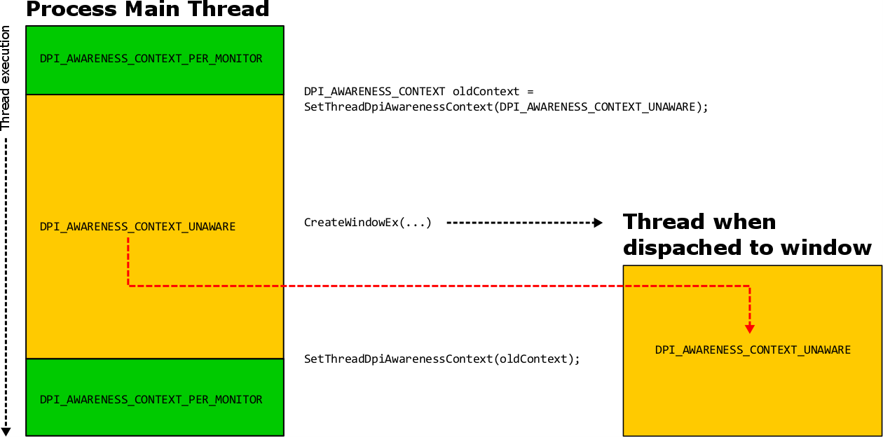

**New DPI-related APIs**

In addition to the support for different DPI awareness modes within a single process that **SetThreadDpiAwarenessContext** offers, the following DPI-specific functionality has been added for desktop applications:

[**EnableNonClientDpiScaling**](https://docs.microsoft.com/en-us/windows/desktop/api/Winuser/nf-winuser-enablenonclientdpiscaling)

**Note**

The **Per Monitor V2** DPI awareness mode automatically enables this functionality, and calling **EnableNonClientDpiScaling** is therefore unnecessary in applications using it.

Calling **EnableNonClientDpiScaling** from within a window s **WM_NCCREATE** handler will result in the non-client area of a top-level window automatically scaling for DPI. If the top-level window is per-monitor DPI-aware (whether because the process itself is per-monitor DPI-aware or because the window was created within a per-monitor DPI-aware thread), the caption bar, scroll bars, menus, and menu bars of these windows will DPI-scale whenever the window s DPI changes.

Note that non-client areas of a child window, such as non-client scroll bars of a child edit control, will not DPI scale automatically when this API is used.

**Note**

**EnableNonClientDpiScaling** must be called from the **WM_NCCREATE** handler.

**The \*ForDpi APIs**

* Several frequently-used APIs such as **[GetSystemMetrics](https://msdn.microsoft.com/library/windows/desktop/ms724385%28v=vs.85%29.aspx)** do not have any context of an HWND and therefore have no way of deducing the proper DPI awareness for their return values. Calling these APIs from a thread that is running in a different DPI awareness mode or context may return values that are not scaled for the context of the calling thread. **[GetSystemMetricForDpi](https://docs.microsoft.com/en-us/windows/desktop/api/Winuser/nf-winuser-getsystemmetricsfordpi)**, **[SystemParametersInfoForDpi](https://docs.microsoft.com/en-us/windows/desktop/api/Winuser/nf-winuser-systemparametersinfofordpi)**, and **[AdjustWindowRectExForDpi](https://docs.microsoft.com/en-us/windows/desktop/api/Winuser/nf-winuser-adjustwindowrectexfordpi)** will perform the same functionality as their DPI unaware counterparts, but take a DPI as an argument and infer the dpi awareness from the current thread's context.
* **GetSystemMetricForDpi** and **SystemParametersInfoForDpi** will return DPI-scaled system metric values and system parameter values in accordance to this equation:

|  |
| --- |
| GetSystemMetrics(...) @ dpi == GetSystemMetricsForDpi(..., dpi) |

* Therefore, calling **GetSystemMetrics** (or **SystemParametersInfoForDpi**), while running on a device with a certain system DPI value will return the same value that their DPI aware variants (**GetSystemMetricsForDpi** and **SystemParametersInfoForDpi**) will, given the same DPI value as input.
* [**AdjustWindowRectExForDpi**](https://docs.microsoft.com/en-us/windows/desktop/api/Winuser/nf-winuser-adjustwindowrectexfordpi) takes an HWND and will calculate the required size of a window rectangle in a DPI-sensitive way.

[****GetDpiForWindow****](https://docs.microsoft.com/en-us/windows/desktop/api/Winuser/nf-winuser-getdpiforwindow)

**GetDpiForWindow** will return the DPI associated with the HWND provided. The answer will depend on the DPI awareness mode of the HWND:

| **DPI Awareness mode of HWND** | **Return value** |
| --- | --- |
| Unaware | 96 |
| System | The system DPI |
| Per-Monitor | The DPI of display that the associated top-level window is primarily located on  (If a child window is provided, the DPI of the corresponding top-level parent window will be returned) |

[****GetDpiForSystem****](https://docs.microsoft.com/en-us/windows/desktop/api/Winuser/nf-winuser-getdpiforsystem)

Calling **GetDpiForSystem** is more efficient than calling **[GetDC](https://msdn.microsoft.com/library/windows/desktop/dd144871.aspx)** and **[GetDeviceCaps](https://msdn.microsoft.com/library/windows/desktop/dd144877.aspx)** to obtain the system DPI.

Any component that could be running in an application that uses sub-process DPI awareness should not assume that the system DPI is static during the lifecycle of the process. For example, if a thread that is running under **DPI_AWARENESS_CONTEXT_UNAWARE** awareness context queries the system DPI, the answer will be 96. However, if that same thread switched to **DPI_AWARENESS_CONTEXT_SYSTEM** awareness context and queried the system DPI again, the answer could be different. To avoid the use of a cached (and possibly stale) system-DPI value, use **GetDpiForSystem** to retrieve the system DPI relative to the DPI awareness mode of the calling thread.

**Note**

The feedback system for this content will be changing soon. Old comments will not be carried over. If content within a comment thread is important to you, please save a copy. For more information on the upcoming change, [**we invite you to read our blog post**](https://docs.microsoft.com/teamblog/a-new-feedback-system-is-coming-to-docs).